Rigid frames, usually referred to simply as frames, are composed of straight members connected either by rigid (moment – resisting) connections or by hinged connections to form stable configuration. Rigid frame implies a plane structural system consisting of straight members meeting each other at an angle and rigidly connected at the junction. The members of frames are usually connected by rigid joints, although hinged connections are sometimes used. A rigid joint prevents relative translations and rotations of the member ends connected to it, so the joint is capable of transmitting two rectangular force components and a couple between the connected members. A rigid connection keeps unchanged the angle between members as the entire frame distorts under load.
RIGID JOINTS:
These are the joints which are capable of transferring axial forces as well as moment. For example Joints provided in the roof slabs.
PIN JOINTS:
These joints are capable of transferring axial forces but cannot transfer moment. For example links of chain in cycle.
If body have no joints it is hard to break because there is no plane of failure.
BASIC DIFFERENCE BETWEEN PIN AND RIGID JOINTS:
In pin joints there is relative rotations between two members whereas in rigid joints it is not possible.
Rigid Frames
Another type of structure that is similar to a truss and capable of carrying external loads. The main different is the way that external loads are applied to them. In frames, members maybe applied at any point of any member. The consequence of the difference is that not all frame members are two-forces which as a result may subjected of bending as well. Portal frames and large frames are common types of rigid jointed frames as the joints are stiff, continuous and moment couples occurred.

Types of Joints
All the structural members in framed buildings or trusses must be adequately connected together so that the applied loads are transferred safely to the ground surface. The types of connection or joints are basically divided into two: stiff and pinned joint.
Stiff Joint
This type of joint considered to have fixity at the point of connection and is rigid as it is sometimes called a rigid joint. The feature is that the flexure of one member meets at the joint has an effect on the other members. If it is perfectly stiff, then the angle between the members remains unaltered while rotation takes place.
Pinned Joint
It is sometimes called a hinged joint. As an example, many roof trusses and bridges are constructed using the pinned joint principles. These joints allow relative movement of the members and they cannot resist bending moments, unlike in stiff joints. Nowadays bolting and riveting are more common used, although the members cannot move relatively to one another, at some degree of rotation were allowed in practice. This is due to to the elasticity of the system and deformations of the members are relatively very small as this the common practice of assuming all joints in a truss to be pinned.
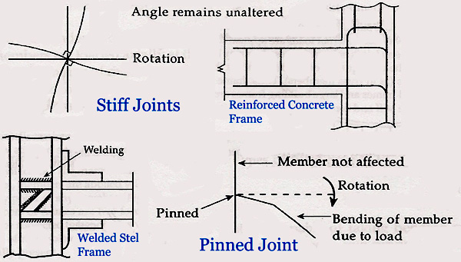

PART – 2
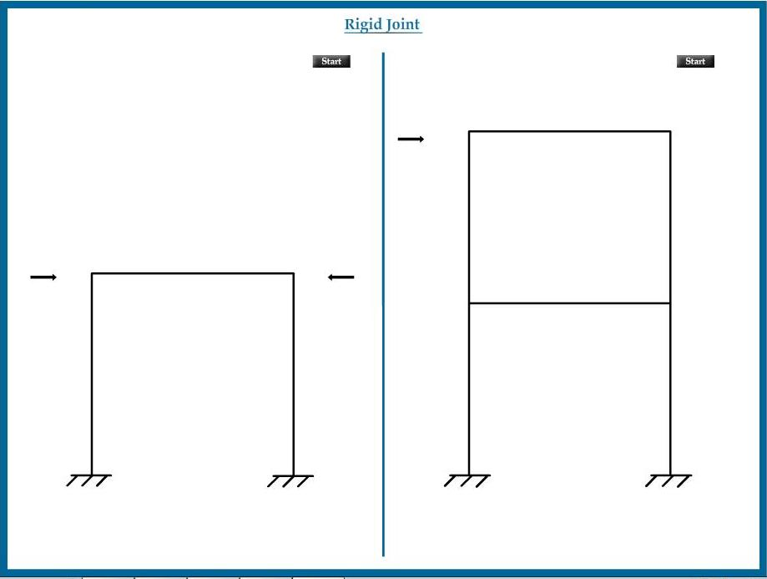
ANIMATION STEPS

PART – 3
VIRTUAL LAB FRAME

